# **RT-HaND_I Radiotherapy Head and Neck XNAT – System Overview, access control and data structure**

Contents

Radiotherapy Head and Neck XNAT – System Overview, access control and data structure 1

1. System overview 1

1.1. Further documentation/information on XNAT 1

1.2. Key contacts 2

2. Information Governance 2

2.1. Anonymisation within XNAT 2

3. Accessing the system 3

3.1. User Access 3

3.2. Admin rights 3

4. Data Structure within XNAT 4

4.1. Pre-archive 5

4.2. DICOM Viewer 5

5. Conclusions 5

## 

## System overview

The Radiotherapy Head and Neck XNAT (RT-HaND_I) is an imaging database containing imaging and radiotherapy planning data, for head and neck patients from the introduction of IMRT (March 2011) to present. There is corresponding clinical data stored within the EDW for patients from 01/01/2010 in a data warehouse (RT-HaND_C) in Electronic Data Warehouse (EDW).

XNAT is a virtual platform capable of storing and managing medical images and associated data. The system is hosted on the GSTT Trust XNAT system, managed by the Clinical Scientific Computing (CSC) Team and supported by Radiotherapy Physics. CSC have their own GitHub page used to share information about the functionality and running of XNAT. This is updated regularly and should be considered the definitive source of XNAT information: [GSTT-CSC/XNAT: Tracks general documentation, standard operating procedures (SOP) and helper scripts for XNAT.](https://github.com/GSTT-CSC/XNAT/tree/main)

### Further documentation/information on XNAT

For more information on the XNAT platform please visit:

<https://www.xnat.org/about/>

XNAT also provides a selection of useful, and very in depth, free online courses, covering a variety of aspects including XNAT administration. These are available to view and enrol onto at:

[xnat-academy.tahoe.appsembler.com](https://xnat-academy.tahoe.appsembler.com/)

For the CSC Standard Operating Procedure (SOP) for uploading data to XNAT, please visit:

[XNAT/docs/SOP-Data-Import.md at main · GSTT-CSC/XNAT](https://github.com/GSTT-CSC/XNAT/blob/main/docs/SOP-Data-Import.md)

The XNAT google discussion group can be a very useful forum, both for posing your own queries as well as being able to see how other groups are using the software and what pitfalls they may have found:

<https://groups.google.com/g/xnat_discussion>

There are several projects on GitLab for various aspects of XNAT use and administration, managed by the KCL-BMEIS group, mostly by Dan Beasley (Daniel.beasley@kcl.ac.uk). Please contact Dan Beasley for access to these – they contain many useful resources including Wiki articles for various processes.

### Key contacts

Clinical Scientific Computing – email: [CSCTeam@gstt.nhs.uk](mailto:CSCTeam@gstt.nhs.uk), website: <https://gstt-csc.github.io/>

Mosaiq/CIS team: [Bill.Dann@gstt.nhs.uk](mailto:Bill.Dann@gstt.nhs.uk)

IG Contacts: [Salim.Badat@gstt.nhs.uk](mailto:Salim.Badat@gstt.nhs.uk)

## Information Governance

The project has been discussed extensively with the Information Governance team, and it was agreed that data could be stored unanonymised, as it is all being hosted on site and access will be controlled. A specific project contains the HNC unanonymised data lake which enables continuous updating of the data. In addition, the Radiotherapy Physics department hosts a separate instance of XNAT (RT-XNAT) designed to uniquely contain anonymised data and cleaned copies of HNC projects. This is linked to CSC-XNAT through opened firewalls and ports enabling data to be sent between the two XNAT instances. The role of RT-XNAT is to enable reusability of data, accessibility of project data (e.g. if asked to reproduce published results) and ensure adherence to data protection principles and information governance.

For individual projects, data will be anonymised and cleaned before being provided for research and a copy of this data will be stored within RT-XNAT.

### Anonymisation within XNAT

Data can be anonymised at multiple points during upload or export from XNAT. The two main points at which data is anonymised are:

* Site wide anonymization: This anonymisation is applied as data is pulled into XNAT and before it is assigned to a project. This site-wide anonymisation applies to data for all projects, and thus is currently very minimal (just removing some unnecessary DICOM tags)
* Project level anonymisation: this is specific for each project and is applied as the data is pushed from the pre-archive into the project archive. The anonymisation script can be accessed from the project home page. Project level anonymisation is also useful for manipulating the naming of data as it is pushed into the project. This is covered in more detail in the technical guide to downloading data from XNAT.

## Accessing the system

On a Trust PC, using the Chrome web browser, access the XNAT web interface at:

[https://sp-pr-flipml01.gstt.local](https://sp-pr-flipml01.gstt.local/)

Access is via personal log in to the XNAT using a username and password (see section “User Access”)

### User Access

User access is managed by the Clinical Scientific Computing team. To request access, please contact CSC ([cscteam@gstt.nhs.uk](mailto:cscteam@gstt.nhs.uk)). The SOP for user access can be found on the CSC’s XNAT Github pages: [XNAT/docs/SOP-Training.md at main · GSTT-CSC/XNAT](https://github.com/GSTT-CSC/XNAT/blob/main/docs/SOP-Training.md).

Before individuals are granted access to XNAT, they are required to undergo a mandatory training session, which is delivered by a member of the Clinical Scientific Computing (CSC) team who has XNAT administrator privileges. These sessions are scheduled as and when new user requests are submitted to the CSC team.

Similar to other GSTT mandatory training, existing XNAT users are also required to periodically retake this training to update their training compliance records in line with the CSC Quality Management System.

GSTT XNAT users must:

* Have a valid GSTT email address
* Have their Information Governance (IG) training up-to-date
* Have ordinary access to the data they will be working with (e.g. PACS access)
* Be able to access the platform whilst connected to the Trust VPN, i.e. either on a Trust computer on-site or via Citrix

Once GSTT XNAT users have undergone the initial training session, they will be provided with a short quiz to test their knowledge. The required pass rate is 80% and users are welcome to both re-submit their answers and reach out to an XNAT administrator for more information and/or further training. Once an XNAT user has acquired a passing mark, the submitted document forms a part of their training log and should be kept for future reference.

Additionally, an XNAT administrator will then:

* Create their XNAT user account and temporary password
* Provide their GSTT XNAT account username, password, project scope, i.e. which projects they have access to, and a link to GitHub XNAT repository via email.

### Admin rights

In order to access some extended elements of the functionality, admin rights for XNAT are required. All existing current processes related to the RTDLHN run without the need for admin rights. CSC have a training and sign off procedure which must be adhered to in order to gain access rights. Please contact Dika Vilic as above to arrange this if needed.

## Data Structure within XNAT

A project in XNAT is used to define a collection of data. The main project for the Radiotherapy Head and Neck XNAT we refer to as RT-HaND_I and has the project IDof “RTDLHN” in XNAT. For work involving a subset of the full database, data can be shared from this main project into a smaller, specific project. XNAT administrators grant access to specific investigators such that XNAT users only have access to data they have the rights to access. XNAT administrators have access to all the data in any project in XNAT and so are subject to enhanced vetting and training procedures.

A subject in XNAT can only exist within a project. A subject is the object of any study, usually (but not limited to) a human patient. A subject record is “owned” by the project for which it was created (in this case “RTDLHN”, but can be shared with other projects for the purposes of work on subsets of the full database. In the RTDLHN project, we have chosen to label each subject with their NHS number to ensure a unique identifier for each patient. You can see a full list of all the subjects within the project by navigating to <https://sp-pr-flipml01.gstt.local/REST/projects/RTDLHN/subjects>

An *experiment* in XNAT is an event by which data is acquired. This can be an imaging session (such as a CT or MRI scan), or non-imaging data. We have chosen to not put non-imaging data in XNAT and so all experiments within RTDLHN are imaging sessions. An experiment must be associated to a subject and exists within a project. In the RTDLHN project, we have chosen to label each diagnostic scan with the Accession Number to ensure a unique identifier for each scan. Radiotherapy data does not have an Accession Number, and so to ensure data is uniquely named, we assign a label to each experiment. These take the form as shown in the table below.

A *scan* is an individual imaging set within a *session.* For example, MRI sessions are often made up of multiple *scans* because multiple sequences are acquired e.g. T1, T2, T2TSE. The same is true of radiotherapy sessions, as a minimum they contain 3 scans: planning CT, structure set and dose cube.

|  |  |  |  |
| --- | --- | --- | --- |
| RT session type examples | Labelling convention | Example | Data element examples (“scans”) |
| Pre-treatment imaging | PatientAriaID_RT_year_AccessionNumber | 3456789_RT_2017_RJxxxxxxxxxx | MRI or CT or PET-CT scans. |
| RT session | PatientAriaID_RT_year | 3456789_RT_2017 | Planning CT, Radiotherapy Structure Set, Radiotherapy Dosecube, Radiotherapy plan, CBCTs (post Aria) |
| RT session replan | PatientAriaID_RT_year_REPLAN/RESCAN | 3456789_RT_2017_REPLAN | Planning CT, Radiotherapy Structure Set, Radiotherapy Dosecube, Radiotherapy plan, registration file |
| RT session (multiple within 1 year e.g. palliative mets) | PatientAriaID_RT_year_BodyPartTreated | 3456789_RT_2017_SPINE  3456789_RT_2017_WHOLEBRAIN | Planning CT, Radiotherapy Structure Set, Radiotherapy Dosecube, Radiotherapy plan |
| On-treatment CBCT (pre-Aria) | PatientAriaID_RT_year_CBCT | 3456789_RT_2017_CBCT | CBCT scan, registration file, possible structure set |

### Pre-archive

The XNAT pre-archive allows data to be manually reviewed before it is assigned to a project. Within each project, it can be set such that all data goes to the pre-archive (and does not archive to a project without manual review), or that data is automatically archived to the project unless there is an error. By default, the RT-HaND_I will allow automatic archive as we are ingesting large amounts of data that would be unfeasible to manually review. However, after any ingestion in is important to check the pre-archive to pick up and resolve any import errors that may have occurred.

### DICOM Viewer

There is an inbuilt DICOM viewer within XNAT which allows viewing and delineation of images. From within a Subject’s summary screen, click “View Images”. Currently dose cubes cannot be displayed within CSC XNAT.

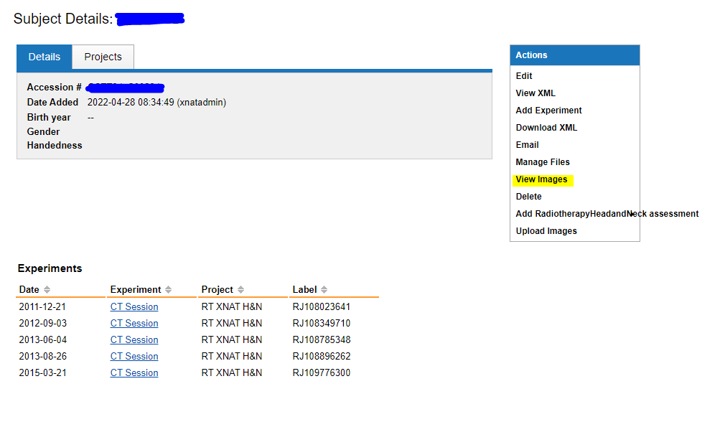

## Conclusions

This document briefly describes the access requirements and data structure within XNAT. It is recommended that users consult the extensive online XNAT documentation, Google group and CSC GitHub when they encounter any errors or queries regarding the technical database structure of XNAT.